Phase 5 Individual Project
Business Plan for HP’S Purchase of CDW
Kenneth C Holmes
IT Management
IT600-1602A-02
Colorado Technical University
May 9, 2016

Table of Contents
Phase 1: Qualitative Evaluation of HP and CDW Page 7
Porter’s Five Forces Page 7
A Brief Explanation Page 7
Threat of New Entrants Page 7
Customers Bargaining Power Page 9
Suppliers Bargaining Power Page 10
Substitute Products and Their Threat Page 10
Competitive Rivalries Page 11
Phase 2: Case Study of HP and CDW Page 14
HP SWOT Analysis Page 14
Strengths Page 14
Weaknesses Page 15
Opportunities Page 15
Threats Page 15
CDW SWOT Analysis Page 15
Strengths Page 16
Weaknesses Page 16
Opportunities Page 16
Threats Page 16
HP and CDW Combined Page 16
Wiseman’s Strategic Thrusts for Strategy Development Page 16
Differentiation Thrust Page 17
Cost Thrust Page 18
Innovation Thrust Page 19
Growth Thrust Page 19
Alliance Thrust Page 20
Phase 3: IT Strategy Statement Page 20
Historical Timelines Page 20
HP’s Historic Timeline Page 21
CDW’s Historical Timeline Page 22
Goals and Values Page 22
HP’s Goals Page 23
HP’s Values Page 23
CDW’s Goals Page 24
CDW’s Values Page 24
Evaluation of Goals and Values Page 25
Critical Success Factors Page 25
Project Goals Agreement Page 26
Well Defined Plans, Responsibilities and Accountability Page 26
Proper Management of Project Scope Page 26
Continuous Communication Page 26
Secure Top Management Support Page 27
Strategy for Obtaining Unity of Goals Page 27
Phase 4: Executive Summary Page 29
Vision Page 29
Mission Statement Page 29
Corporate Values Page 30
Major Goals Page 30
Marketing Analysis Page 31
Target Markets Page 31
Marketing Strategy Page 31
Marketing Strategy SWOT Analysis Page 33
Financial Statements Page 34
CDW Financial Statements Page 34
HP Financial Statements Page 35
Financial Statements Analysis Page 36
Porter’s Five Forces Page 36
Threat of New Entrants Page 37
Customers Buying Power Page 37
Suppliers Buying Power Page 37
Substitute Products and Their Threat Page 38
Competitive Rivalries and Their Intensity Page 38
Unification of Objectives and Values Page 39
Conclusion Page 39
Phase 5: Project Management Plan Page 40
Initiating Page 40
Planning Page 40
Scope Page 40
Integration Page 42
Cost Page 42
Time Page 42
Executing Page 42
Procurement Page 43
Quality Page 43
Risk Management Page 44
Human Resources Page 44
Monitoring and Controlling Page 45
Stakeholder Management Page 45
Communications Page 46
Closing Page 46
Gauging Success Page 47
Summary Page 47
References Page 48

Business Plan for HP’s Purchase of CDW
Hewlett Packard (HP) has been in partnership with CDW since 2008, and the partnership has proven profitable for both firms. The premise of this business plan is the acquisition of CDW by HP. Naturally, any acquisition requires research and analysis, and this business plan addresses the necessary research to make the most educated decision. The business plan has five phases: Qualitative Evaluation, Case Study of HP and CDW, IT Strategy Statement, Executive Summary, and Project Management Plan.
Phase 1: Qualitative Evaluation
Porter’s Five Forces
A Brief Explanation. Porter’s Five Forces technique is effective for analyzing and evaluating the five major forces that shape any competitive industry, and the five forces include: Threat of New Entrants, Bargaining Power of Buyers, Bargaining Power of Suppliers, Threat of Substitution, and Industry Competition. Porter’s technique is an easy and convenient method for creating a SWOT analysis for identifying an organization’s current strengths and weaknesses, seeking industry opportunities that may be of interest, and identifying and addressing head on any threats that currently exist. Additionally, Porter’s technique provides a complete and comprehensive understanding of the current structure and evolution of an industry, and provides all the necessary tools to create the ideal competitive strategy, business strategy, and information system strategy, and align the three strategies to provide the roadmap, and create a strong competitive advantage for success in the current industry climate (N.A, 2016).
Threat of New Entrants. The IT services sector is not difficult to enter, but requires specific skills, certifications, licenses, insurance coverage, and of course funding. The credentials for education include: A Bachelor’s degree and above in the field of computer technologies (Computer Science, IT, Computer Networking, and so on) from a reputable school; Certifications including: Microsoft Certified IT Professional (MCITP): for database and server administrators, Microsoft Certified Technology Specialist (MCTS): for installing, maintaining and troubleshooting, CompTIA Security +: to establish proficiency with IT security, Microsoft Professional Developer (MCPD): for designing and maintaining software solutions, Cisco Certified Internet Expert (CCIE): for networking proficiency, CompTIA A+: for hardware and software installation, support and diagnosis, Project Management Professional (PMP): for establishing project management expertise, Microsoft Certified Systems Engineer (MCSE) and Microsoft Certified Systems Administrator (MCSA): for demonstrating expertise from client and server administration to security, Certified Information Systems Security Professional (CISSP): to establish expertise with operations, networks and physical security, and Linux+: for establishing Linux client and server expertise. This list is based on the ten most desirable certifications. Having a solid background and certification is a strong strategy for building customer confidence, and attracting a wide variety of clients (Eckel, 2008).
Having the right tools for the job is a necessity, and any IT professional should have a complete toolkit with hardware and testing equipment (including portable devices) kept in the office, and for onsite assignments. An IT business requires a business license before you open your doors, provides the business legality and legitimacy, and only entails filing a few documents and paying a fee. To make the business more professional, having an office to receive calls and clients will establish legitimacy, and build a professional reputation. The office does not need to be fancy, only requires a desk, chairs, computer, printer, and a phone line, but should be clean, professional and inviting. Prior to opening the doors, it is necessary to establish up to three service packages, with different monthly fees for each, based on level of service, to provide a broad range of services and clients. Additionally, the IT business owner (s) should network themselves, have business cards printed for handing out to potential clients, and anywhere soliciting business is allowed, and becoming a member of the cities Chamber of Commerce is always helpful for building a strong reputation (N.A., 2016).
Based on the above requirements, starting an IT business is not necessarily difficult, but takes time, education, certifications, licensing, commitment, and start-up cash, which is usually the reason for delay or failure of the business. Since the IT sector is an oligopoly, with a few large players, and many smaller players, the biggest threat to new entrants comes in the form of start-up costs, the major U.S. players, and from the international sector, where the industry players perform as monopolistic competition, which is far more competitive that the domestic market alone.
Customers Bargaining Power. Since the IT industry if fiercely competitive, based on levels of technology, need, and products and services priced at different levels for different customers, the client has some bargaining power. For those reasons IT providers offer at least three levels of technology and services. The reality is not every client needs or can afford the most powerful system available, but every client requires a system based on their needs and budget. Small companies will likely require a system that is less robust and costly, and is easy to upgrade and modify, based on the growth of the company. Larger companies will require systems that are more robust, and can handle large quantities of data and storage, which will also cost more. Based on the client’s needs, they have some bargaining power, but when a business owner needs an IT system, they must take into account the system must be based on the needs of the business, and that will determine the features, capabilities, power, and cost.
Suppliers Bargaining Power. Suppliers power is based on the supplier’s ability to establish the quantities supplied and the price of the product to market, the contract terms, and is determined by the number of buyers and suppliers in the industry. In the IT industry, there are a few major players and many minor players. The larger the company, the more power they have over the supplier, and most larger companies produce many of their own products, or have contracts with reputable third parties to produce their products. Smaller companies are more at the mercy of suppliers, since they do not have the buying power. A reputable supplier will realize they are not the only player in the game, and should be careful not to overplay their position in the industry. If a supplier does not consider a particular buyer important enough, and price gauges that buyer, or reduces the quality to generate higher profits, that buyer can contract with another supplier. Additionally, they must take into account today’s smaller buyers may become tomorrow’s major players, which can place that supplier in a very profitable position (Ryszard, 2014).
Substitute Products or Services. IT industry standards are established by the Information Technology Standards Committee (ITSC), and by industry agreement, and require a two-month industry review by the World Trade Organization Technical Barriers to Trade (TWO BT), prior to their publication. The standards can constitute code of practice, guide, specifications, testing methods, terminology or management system. Industry conformity is on a voluntary basis, unless it has been specified through legislation of the regulatory bodies, at which point is becomes the law of the industry. Standards are necessary for providing cost reductions, new clients, product differentiation, risk reduction, encourage and support technology innovation, and to ensure industry compatibility of equipment and systems (N.A., Singapore IT Standards, 2016).
Since the IT industry is based on required compliance standards for compatibility, in theory, every system should function based on the same industry standards and requirements, making the threat of substitute products and services very real. There are some companies that offer proprietary systems, and clients must be mindful to ask the right questions to determine the best choice of system to design and build, and be assured their compatibility with other industry technology. Most companies offer IT infrastructures and services that are fully industry compliant, making changing services relatively simple. The biggest issues with changing services is the new service will have to work with the existing structure, and based on many IT professional’s experiences, that is where the issues begin. Translation, often IT professionals are forced to ask “why did they use that network arrangement”, forcing the new IT service to plan based on the current configuration, which may not have been the ideal configuration.
Competitive Rivalries. The IT industry if fiercely competitive, is defined by continuously changing technology, the evolution of industry standards, new technology and product entries to market, improved product efficiency and reduced costs, and demand based on IT models, pricing, and the demand for the products and services. There are many factors that drive IT industry competition including: The budgets and desired technologies of current and potential clients, the merger and acquisition of competing companies, the continuous demand for reduced costs and performance improvements, the application of aggressive pricing tactics and product and marketing strategies, and difficulty in sustaining product differentiation because of continuous technological improvements, which also affects a company’s ability to compete in the global market place. For any company to be successful in the IT industry requires much effort on the part of the provider including: Making research and development of new and improved IT solutions that respond to market demands a top priority; and establishing economies of scale, whether through the sheer size of the company, efficiency in production, and maintaining low costs of inputs and high profits, while still maintaining high quality products and services (Competition in The Information Technology Industry, 2009).
There are several rivalries that require discussion, and all involve HP. The first involves the rivalry between Intel and AMD, and their dual core microprocessor race. Both companies were competing to introduce their new dual core processors for HP’s new servers, and deliver on their promise of speed and performance at affordable prices in mid-2005. The irony is that IBM, Sun Microsystems, and Azul Systems had already begun shipping their multi-core (up to 24 core) processors prior to the release of both Intel’s and AMD’s (McCarthy, 2005).
The second involves Dell and HP. The year 2009 had HP beating their industry rival Dell, but this was just the start for Dell, because Dell was starting a full diversification strategy from hardware, into everything, and has since made major strides in business growth and revenue generation (N.A., HP, Dell rivalry hinges less on selling PCs, 2009).
The third involves HP, Dell and Cisco. HP has major plans on overtaking both Dell and Cisco. First, HP introduced their open platform servers to overtake Cisco’s closed (proprietary) platform, and the plan is working since HP has taken two thirds of the market share Cisco lost. Next, HP introduced their Open Flow, software defined network servers, which served as the less costly industry alternative to Cisco’s “intelligence” switches. Dell has since pushed forward with their introduction of open network technology, and the three companies are still battling it out. For the industry and the consumer, rivalries are a good thing, since they push technology providers to create better and less costly technology, and lead to great advancements in the IT and technology sectors (Bort, 2012)
The top competitors in the U.S. based IT sector include: IBM, HP/CDW, Oracle and CSC (Computer Sciences Corporation). Each have extensive financial reserves, tremendous buying and marketing abilities, extensive brand name recognition, and a large variety of IT industry services and platforms. This list only accounts for IT services, and does not include Business Process Outsourcing services (BPO), Research & Development services, and software or hardware products. Additionally, many smaller companies are building their service and client portfolio, and preparing to compete with the major players, making the IT industry more complicated, competitive, and challenging for revenue generation (Phadnis, 2014).
The top global competitors in the computer industry from first to tenth include: Apple, Hewlett-Packard (HP), Dell, Microsoft, Lenovo, Acer, Samsung, Sony, Toshiba and Asus. The computer is necessary because it is how the end user connects to the internet and the world, is a big part of the IT industry, and many computer manufacturers also provide IT services. Ironically, the top four computers are all U.S. based manufacturers, indicating a clear sign that the U.S. is on top of communication technologies, and is able to maintain their position through quality products, and top notch technologies (N.A., Top Ten Best Computer Companies, 2015).
The top global competitors in the software industry from first to tenth include: Microsoft, IBM, Oracle, SAP (German based), Symantec, EMC, Hewlett-Packard, VMWare (a division of EMC), CA Technologies and Salesforce.com. The software industry is necessary because it drives the hardware, and is an integral part of the function and performance of IT hardware and systems. Ironically, nine of the top ten software companies are U.S. based, produce and sell computers and IT systems, and once again proves the U.S. is on top of communication technologies, and is more than able to compete and maintain their position through top quality and dependable software design (Shobhit, 2016).
Phase 2: Case Study of HP and CDW
SWOT Analysis
HP SWOT ANALYSIS
Strengths | Weaknesses
2nd largest player in the U.S. IT industry, and software solutions | Uses CDW and other service providers to execute many of their services
Full spectrum client base from small to medium business, retail, education and healthcare industries
Diverse product line including: Computers, printers, mobile devices, and business solutions including: printing, mobility, broadband service, computing, security, software, financial and IT services
First quarter 2015 $26.8 Billion in revenues
A strong commitment to excellence in all services provided
HP has taken two-thirds of Cisco's market share
Opportunities | Threats
Merger or acquisition of CDW by HP would combine the forces of two top industry IT service providers | IBM, Oracle and CSC are their top U.S. competitors are always working on the next generation of technology, and striving to provide the best services for their clients
Combined forces would enable tremendous product and service expansion for both, and greater international influence

Strengths. HP’s strengths are defined by their product line and client services, providing their ability to meet the full spectrum of IT needs for small to medium sized businesses in retail, education and healthcare. HP has a strong commitment to service excellence, and it shows with HP taking two-thirds of Cisco’s lost client base, and by generating $26.8 billion in the first quarter of 2015.
Weaknesses. HP’s biggest weakness is their dependence on the independent firm CDW, and their numerous other service provider, and actually represents an interdependence on each other, which works more like a partnership, and is beneficial for all parties.
Opportunities. The acquisition or merger of HP and CDW provides a tremendous opportunity for both parties, would provide the launching pad to make HP the leader in the IT industry.
Threats. The biggest threat for HP is their competition, IBM, Oracle and CSC. Competition will always be a threat to each and every player in the IT industry, since competition drives the industry, and is the primary thrust for innovation and efficiency.
CDW SWOT ANALYSIS
Strengths | Weaknesses
2nd largest player in the U.S. IT industry, and software solutions | Heavily dependent on their many business partners for their products and clients
Full spectrum client base from small to large business, government, education and healthcare
Diverse product line including: hardware, software, desktops, printers, monitors, integrated IT solutions, networks, mobility, security, data center optimization, cloud computing, virtualization and collaboration
End of year 2015, sales of $12.9 Billion +
Fortune 500 company, listed on NASDAQ
Strong commitment to meeting customer needs through quality products, services and long-term client relationships
Mission of absolute excellence
26 locations, with 250,000 clients
Opportunities | Threats
Merger of acquisition of CDW by HP would combine the forces of two of the top IT service providers | IBM, Oracle and CSC are their top U.S. competitors, and are always striving to provide the best technology and services for their clients

Strengths. CDW’s strengths are defined by their product line, providing their ability to meet the full spectrum needs of small to large business, government, education and healthcare organizations. CDW’s mission of excellence has a proven track record, from starting out as a small one-man business, to their expansion into 26 locations, over 250,000 clients, generating $12.9 billion for the year 2015, and their fortune 500 company listing.
Weaknesses. CDW’s biggest weakness is their dependence on their many business partners for products and clients, but there is an interdependence on each other, which creates a strong bond between those partners, especially HP, and is beneficial for both parties.
Opportunities. CDW’s has a tremendous opportunity by being acquired by or merged with HP. An acquisition or merger would provide both firms the benefit of their IT expertise, and a launching pad for massive growth, expansion, and revenue generation.
Threats. For CDW, the threats are the same as for HP, the industry they conduct business in, and the competition: IBM, Oracle and CSC. The fact still remains that competition drives the IT industry, and will always be a driving force behind technology, speed, and efficiency.
HP and CDW Combined. The combined forces of HP and CDW would provide for the continuous sharing of technology and information, and would enable both organizations to expand their product lines, services and client base, and provide both organizations the ability to dominate the IT industry.
Wiseman’s Strategic Thrusts for Strategy Development
Based on Wiseman’s framework of strategy development, a full understanding and evaluation of the five thrusts are necessary for creating the best information systems management plan, and maximizing the organizations competitive advantage, and those five thrusts include: differentiation, cost, innovation, growth and alliance. Additionally, suppliers, competitors and customers constitute the primary contributors to the plan. The following section analyzes and explains the forces that drive the IT industry, and their influence on a strong information system management plan (N.A., Definition: Strategic Thrusts Wiseman, 2016).
Differentiation Thrust. Product differentiation is a necessary strategy to separate one firm from another, provides a firm their own identity, provides a barrier for the competition to address, and is part of a firm’s competitive advantage. For HP product differentiation is achieved by providing: A wide array of products and services that address a full spectrum of customers, from small to medium business, and includes retail, education and healthcare; Perceived value created through superior technology at lower prices; Designing IT system of superior quality, functionality, compatibility, expandability and longevity. These features create a benefit that is difficult and costly to duplicate; Establishing brand loyal clients by providing top notch products and services, and continuously reinforcing their commitment to clients; and lastly, by creating the perception of product differentiation based on quality of product and service, and the perception there are no suitable substitutes. CDW product differentiation is achieved by: providing products and services that address a full spectrum of customers, from small to large, and include business, government, education and healthcare industries; product and service customization; and through their firm commitment to meet their client’s needs every time (Kelchner, 2016).
IBM provides IT solutions for the following industries: Hospitality, retail, education, healthcare, veterinary medicine, automotive, athletics, banking, insurance, economics, risk management, government and entertainment. IBM has achieved product differentiation through Watson, which is a cognitive platform: an intelligent platform that applies understanding, reasoning and learning to provide better solutions, and works with the IBM cloud to utilize dark data, the 80% of data that most businesses do not see, and put it to work. Watson has proven itself highly effective for building stronger businesses. IBM also manufactures and sells computer hardware and software, and provides infrastructure, hosting and consulting services for mainframe computers and nanotechnology. For a company whose origins began in the 1880s as a holding company for three technology firms, IBM’s success is duly noted by their tremendous growth, revenues, and because they are number two in the IT industry (N.A., IBM: Cognitive Systems, 2016).
Oracle provides IT solutions for the following industries: Aerospace, defense, chemical, automotive, communications, consumer goods, education, financial services, healthcare, insurance, retail, entertainment, travel, natural resources, utilities, wholesale, and many others. Oracle achieves product differentiation through the utilization of technologies that provide clients differentiation in their products and services, lower operating costs, maximize profits, the utilization of the most comprehensive suite of standards based tools for integrating and leveraging legacy systems, and by helping clients win and retain business, key employees, and by handling highly complex global projects (N.A., Oracle Business Services, 2016).
Cost Thrust. Cost reductions are driven by established industry standards, the need to continuously improve efficiency and cost of production, client needs and budget, and are a major driving force behind product innovation. For HP and CDW, cost reductions are the major driving force behind their technologies, their overall efficiency, profitability, and are achieved through innovation, production efficiency, complying with IT industry standards, partnerships with reputable and reliable technology product manufacturers, and direct manufacturing and control of the production process. IBM controls costs by applying the newest technologies, manufacturing efficiency to control costs, and intuitive technology to generate cost savings. Oracle controls costs by applying industry standards that drive product innovation, manufacturing efficiency, and a comprehensive array of products and services for all industries.
Innovation Thrust. Innovation is one of the key factors driving IT sector growth and revenue, and both HP and CDW are global innovation leaders in the IT industry. While some firms focus their efforts on designing system that are proprietary, HP focuses their efforts on open platform systems that meet established IT standards, and are compatible with all industry standard equipment, regardless of manufacturer. CDW focuses their efforts on providing every client industry standard and compatible equipment, and tailoring their hardware, software, and networks to deliver cost effective and sustainable results. IBM’s innovation involves intuitive technologies, that actually think and reason, and utilize unseen data to enhance business. Oracles innovation is driven by management’s passion for everything innovative including: Bring your own device (BYOD), social-media policies, and incorporating their software solutions into every product and service and workflow they offer (N.A., Innovation and the CIO: 5 Great Ideas, 2016).
Growth Thrust. CDW has grown from a small computer broker company to the nation’s second largest it provider, with 2015 sales of $12.9 billion. HP has grown from working in a make shift office out of Palo Alto garage, with their first product, a resistance capacitance audio oscillator, used to test sound equipment, to earning over $111 billion, with a full spectrum of products and services to meet today’s IT needs. Both firms have seen tremendous growth and revenue generation, and credit their success to their dedication to providing technology that is of the highest quality and compatibility, and their commitment to providing superior clients services (N.A., Timeline of our history, 2016). IBM has grown from a holding company in the 1880s, to a global business and IT solution giant with revenues of $81.74 billion for 2015. Oracle has grown from their early days as a database provider, to a comprehensive portfolio of IT business solution, with revenues of $38.23 billion for 2015 (N.A., Annual Financials for Oracle Corp, 2016)
Alliance Thrust. CDW has partners in every spectrum of the IT world including: Acer, Adobe, Apple, Asus, Belkin, Brother, Cisco, Dell, Google, HP, IBM, Intel, Microsoft, NEC, Net Gear, Oracle, Xerox, and many others. CDW’s commitment to meeting client needs through quality products, services, and long-term client relationships, is the major driving force behind their partnerships. HP’s partners include ARUBA, CDW, Java, Linux, Microsoft, Mainline Information Systems, and many others. HP’s full spectrum of quality and dependable products, and professional services provided through their partnerships helps HP meet their client’s IT needs, and build strong and long-term provider client relationships.
IBM has many partnerships including: Citrix, F5, Juniper, Lenovo, Mobile Iron, Motorola and NetApp, all of which help provide IBM’s mobile, server infrastructure, networking and consulting services (N.A., IBM and alliance partner joint solutions, 2016). Oracle has many partnerships including: Mannai Trading company, NEOS, NEC, Accenture, Hitachi, Infosys, and many others, and all of their global partners help Oracle provide the full array of products and services to their global clients.
Phase 3: IT Strategy Statement
Historical Timelines
HP’s Historical timeline. To illustrate HP’s growth from its humble beginnings to being a global IT giant, a brief stroll through HP’s progression is necessary. HP started out in 1938 as a computer broker working out of a Palo Alto home garage, moved into their first office in 1940, with their first product, a Resistance Capacitance Audio Oscillator, which was developed to test sound equipment, and has grown into a global IT giant, with separate divisions for each aspect of the industry, which allow for independent R & D, production and marketing programs. HP’s global expansion began in 1959, with offices in Switzerland and Germany, and now all over the globe. HP became a Fortune 500 company in 1962. 1966 began HP’s entrance and expansion in the computer and IT industry with the first plug and play HP 2116A computer, and has added an arsenal of products since including: The HP 300 business data processor in 1972, HP IB interface bus which became the global standard in 1975, the HP 150 computer with touch screen in 1983, HP RISK architecture in 1986, the HP Deskjet printer in 1988, the first x86 server built to industry standards in 1989, the Proliant 4000 industry first rack mounted server, the HP Pavilion PC in 1995, the Superdome Server Line for internet infrastructure in 2000, the Halo Collaboration Studio enabling virtual long distance coloration, the all-in-one Touch Smart PC and tablet in 2007, and their most recent addition the HP Spectre Laptop, the worlds thinnest (N.A., Timeline of our history, 2016).
HP has also expanded their IT empire through acquisitions including: F. L. Moseley Company in 1958, which became the foundation for the HP printing division; the merger of HP and Compaq in 2002; Snapfish in 2005, an online photo service; Scitex Vision in 2005, a producer of wide and super-side format printers; Electronic Data Systems (EDS) in 2008, an industry leader IT service company; 3 Com Corporation, a networking, switching, routing and security solutions leader, and Voodoo, a high performance laptop producer, all in 2009; 3Par, a leading storage provider, Fortify Software, a security assurance company, and ArcSight, a security and compliance management company, all in 2010; Autonomy Corporation PLC in 2011, a global infrastructure software company; ARUBA Networks in 2015, an industry leader of mobility software and WLAN hardware (N.A., Timeline of our history, 2016).
Analysis of HP’s history shows a clear growth and expansion pattern, and the acquisition of many IT firms, expanding their family of companies, and the start of HP’s domination of the IT world.
CDW’s Historical Timeline. CDW started out as a small computer broker, and has grown to the nation’s second largest IT provider. CDW’s partnership with HP started in2008, and became one of their small to medium IT business solution providers. This move did not sit well with HP’s other partners, but has proven lucrative for both HP and CDW. As a result of CDW’s partnership with HP, their revenues for 2015 were $12.9 billion, and HP’s revenues have grown to over $111 billion (N.A., CDW Homepage, 2016).
Goals and Values
Because neither HP and CDW have an official mission statement, they run the company and conduct all of their business based on their goals and values, and use them as their roadmap for success. For the purpose of simplicity, the best way to approach unity of goals and values is to discuss them.
HP’s Goals Include (Jurevicius, 2013):
- Earning client loyalty and respect by providing the best quality and value in every product, service and solution we offer.
- Achieving financial prosperity by effectively and ethically generating profits, and building shareholder value in every business transaction we conduct.
- Develop and expand on company strengths and proficiencies by seeking every possible opportunity for growth.
- Maintain market leadership through innovation in ever product, service, and personal and business solution we provide.
- Reinforce our dedication to employee success through performance based rewards and promotions, and by fostering a collaborative and values based work environment.
- Providing training and discipline to create strong industry leaders, and instilling professional values and a solid business mentality.
- Reinforcing our commitment of global responsibility through proactive financial, intellectual and social efforts wherever we conduct business.
HP’s Values include (Jurevicius, 2013):
- Proactively treat everyone with respect and dignity, and foster an environment based on the freedom to generate ideas, and a firm belief in respect, dignity and trust.
- A firm belief that all efforts are essential to achieve industry excellence and success in all endeavors.
- Proactively encourage teamwork and collaboration, and strive for efficiency in every client transaction.
- Continuously strive to achieve the highest quality and essential innovations in every product and service we provide.
- Foster and instill total honesty and integrity in everything we do
CDW’s goals include (N.A., CDW Homepage, 2016):
- Conduct every business transaction with integrity and passion, and treat all stakeholders with respect and dignity.
- Proactively treat every employee with respect and dignity, and empower all employees to perform their job with proficiency and dedication to perform at their best.
- Proactively maintain every commitment, and treat every client with the utmost respect and courtesy.
- Proactively resolves all conflicts, and seek resolutions to inhibit them from happening again.
- Proactively listen to every client, and strive to deliver the products, services, and business solutions that meet their needs.
- Proactively include all stakeholders in every decision, and strive for personal excellence in every transaction.
- Proactively seek the best solutions for every client, and make everything possible
CDW’s Values Include (N.A., CDW Homepage, 2016):
- The only successful transaction results in a win/win for all
- Hard work is the only work we know
- Business succeeds because clients like who they are working with
- Continuously seek perfection and you will achieve excellence
- Addressing weaknesses and not resting on success results in long-term growth and success.
- Being successful means never being satisfies with your best
Evaluation of Goals and Values. Based on the goals and values of both HP and CDW, their organizational structure and approach to business are almost identical. Both companies conduct business in the same manner, have the same dedication to employee growth and success, and the same approach to treating the client with respect and listening to their concerns, and achieving business excellence. The challenge in this case is convincing both parties that the acquisition of CDW by HP would be in the best interest of both parties, and convincing both parties to negotiate a fair and profitable partnership. HP would gain by having CDW as part of their IT arsenal, CDW would gain by being an exclusive provider of HP’s IT services, and both firms would see tremendous business and revenue growth, product and service innovation, enhanced client services, and a growing client portfolio. Since CDW has been the contract provider for the products, services and solutions HP offers, the acquisition of CDW by HP would be a natural progression for both companies, and would fit with HP’s history of acquiring partner firms. With the combination of HP and CDW as partners in the IT world, the competition would have to take notice.
Critical Success Factors
Every strategy requires specific factors to be achieved to ensure both successful planning, execution and follow-up, and IT strategies are no different. The following is a list of critical success factors essential for any IT project to be successful, and includes the following (Hughes, 2010):
- Project Goals Agreement. For the HP and CDW IT project managers this is essential. All stakeholders including: Top management, Finance manager, IT managers of both firms, and project team members must all be in agreement regarding the purpose, goals, and desired end result of the acquisition project, and sign off on all aspects of the agreement. This includes agreement on: All weaknesses or threats the project will resolve, the results all parties want to achieve, and the missing piece of the puzzle the project will fill. All project goals must be realistic, achievable, transparent, specific, and measurable.
- Well defined plans, responsibilities, and accountability. The planning process is key for a successful IT project, and means that every aspect of the project must be accounted for, costed and scheduled, and includes materials, labor, team planning and updates, determination of scope, full risk assessment and contingency plans, and include proper completion dates for each phase of the project. The plan must also delegate and determine responsibilities and accountability. The plan must also be updated to account for finished and unfinished portions, and account for cost and time delays or savings.
- Proper Management of Project Scope. Since the scope and goals are determined during project planning, it should be a matter of staying focused. However, unexpected changes (scope creep) often occur, and must be handled. This means the IT manager must determine whether the changes are necessary, what effects the changes will have on budget and schedules, and determine whether all stakeholders have agreed on the changes, and enforce the project agreement if the changes are unnecessary.
- Continuous Communication. Timely communication is essential for keeping all stakeholders and participant up-to-date on project progress, and includes: Routine team meetings to discuss project progress or delays, budget, schedule, changes to the plan, and all information relevant to the project; Routine client updates to keep the client in the loop, and a full review of project progress, and all information relevant to the project parameters; and lastly, routine supplier updates, provide purchase orders, payments, and review of project progress. All stakeholders in the project should know who the IT manager is, and have regular face-to-face communications, and not just by phone or email.
- Secured Top Management Support. The success of any project requires the full understanding and support from top management. This means Top management fully understands the importance, the issue or gap the project resolves, the value the project adds to the company’s big picture, their inclusion of the project as a priority, and their participation in every step of the project. Without the full support of top management, the project will likely fall to the waste side when funding is needed for another project, will have no chance of succeeding, and will ultimately be pulled for priority projects.
Strategy for Achieving Unity and Support of Goals
For acquisition talks to be successful, IT managers must ensure specific steps and preplanning are in place, not only for smooth and productive negotiations, but to establish any SIS changes that may need to be implemented, to provide full communication of information, once the acquisition is approved and completed. Additionally, the acquisition of CDW will require the consent of both organizations, a unity of the goals and objectives for both companies, and the cooperation of both parties to ensure a smooth transition for the two to become one entity. The unity in goals is essential to ensure both companies are on the same page, and to make the transition from two independent firms into one firm as smooth as possible. The IT department requirements include.
- A meeting of the minds will be held, with the attendance of representatives of both HP and CDW including: IT management, top management, and finance. The discussion will evolve around the goals and values of both firms, and focus on how the two firms will merge their goals and values into one cohesive set of goals and values.
- All parties will be required to participate, provide their input, explain their position, and ultimate agree on one cohesive set of goals and values, and follow into acquisition talks with the agreed upon goals and values.
- Once agreement has been achieved, all parties will contractually agree with their signatures on the contract, and comply with the newly established unified goals and values.
- Upon completion of the agreement, the IT project teams will be established, both HP and CDW IT managers will arrange a full evaluation of their current IT infrastructures, and determine if any updating is required, determine compatibility, and whether the infrastructures meet the needs of the newly established mission, goals and values.
- Once evaluation is completed, the teams will conclude, based on the full analysis of their infrastructures, what needs to be done to provide the ideal infrastructure for the new goals and values. Then work will be started to establish the ideal infrastructure.
- If changes need to be made to the infrastructure, the IT teams will meet with all stakeholders, and establish all details of the plan, scope, full risk assessment and contingency plans, full documentation of completion for each phase of the project, and include assigned responsibility and accountability for every aspect of the project. The document will be signed by all stakeholders, and will serve as the cornerstone for all decisions.
- Time frame for infrastructure evaluation will be four (4) months.
- If changes need to be made to the IT infrastructure, the time frame will be based on the extent of work involved, and will be planned and executed in an appropriate and timely basis.
- This process will be both a prerequisite for acquisition talks, and part of the talks, and will stand as the cornerstone for all future negotiations.
Phase 4: Executive Summary
Vision. The true vision of Hewlett Packard is to continue our path of social responsibility by expanding the educational experience to encourage and foster today’s younger generations, from all walks of life, to think critically about how to solve current and future global issues. The purpose is to encourage entrepreneurship and education in today’s young generations, to enhance their potential, and make the world a more productive place. To accomplish this, HP has created their Sandbox and STEM Program initiatives. The Sandbox program is a virtual reality online student experience, which enables students from all corners of the world to access (STEM) science, technology, engineering and math programs, collaborate with other students from around the globe, and encourage collaboration to address environmental and social issues around the world. The premise of the program is to provide students the tools necessary to foster critical thinking and problem solving capabilities, and encourage today’s young generations to become tomorrow’s global problem solvers and entrepreneurs (Korngold, 2012).
Mission Statement. The mission of Hewlett Packard is to foster an environment of collaboration and teamwork, continually improve the efficiency and capabilities of our technology, provide all clients superior service and workmanship, exercise every opportunity for growth and development, utilize our profits to build value for all stockholders, and continue our role as the industry leader of IT products, services and solutions. Our mission is accomplished through employee and client collaboration, listening and addressing ideas and concerns head on, our commitment to treating every employee and client with respect, dignity and trust, providing employee rewards based on performance, turning employees into leaders at every level, and by earning the clients’ loyalty by providing the best quality and value in everything we do (Jurevicius, 2013).
Corporate Values. At Hewlett Packard, our values are simple and never change. HP prides itself on a corporate culture based on mutual respect, trust and dignity for everyone, seeking our best and achieving excellence, achieving the highest efficiency and results through team collaboration, always striving for the best and most practical technological innovations to meet our client’s needs, and always being truthful and sincere in all transactions (Jurevicius, 2013).
Major Goals. At Hewlett Packard we take great pride in our corporate goals and values, and continually strive for perfection, so our goals include (N.A., Data and Goals, 2016):
- Continuing the application of social media tools for employee training, and public and business communications.
- Enhance and continue the application of anti-corruption training for all employees, and foster honest and integrity in all we do.
- Continue encouraging collaboration and teamwork through the utilization of outside vendors and IT service providers.
- Expand employee ethics and compliance training, and continuously foster a corporate culture based on honest, trust and respect.
- Continuing HP’s policy of achieving customer loyalty through our values, and superior product and service quality.
Marketing Analysis
Target Markets
HP’s target markets include:
- Small to medium businesses, and includes the retail, education and healthcare sectors
- Mass market sector for home and home office needs
CDW’’s target markets include:
- Small to large businesses, and includes business, education, government and healthcare sectors.
- Focus on business IT products and solution
Marketing Strategy
At Hewlett Packard, our marketing strategy is based on many factors including (N.A., Hewlett Packard Marketing Mix, 2016):
- Offer an array of products, services and solutions to meet the needs of our global clients including: Information technology infrastructure, business outsourcing, networking products and services, application development and support, consulting and integration services, software development services, and computer and printing products and services for home and business.
- Promoting the pay-per-use utility pricing programs on Superdome servers, which measure the use of each CPU, and reduces the client’s bill during slow periods.
- Promoting client services that determine budget first, and build a system that meets their needs, based on the budget.
- Providing subsidiary offices in major cities around the world including: Miami, Ontario, Geneva, Tokyo, Houston, Singapore, Victoria and Rivonia.
- Providing the HP website which offers customers our partner locator service, which enables customers to determine the most suitable service based on the size of their business, home or office, and products needed.
- Promoting HP’s trade in policy, where the customer can obtain a free quote, and use for upgrading to a new eligible device.
- Promoting HP’s employee blog, which enables customer to read posts on networking, server, software and storage solutions.
- Promoting 0% financing for qualified buyers on select products and services
- Employing people who are well trained and competent, and fostering an environment that celebrates individual ideas and teamwork.
- Introducing CDW into the HP family of service providers, and promoting their mutual dedication to quality products, services and solution to meet all client’s needs.
- Extensive use of social media platforms to promote CDW, and their extensive selection of products, services and solutions.
- National television advertising campaign promoting both business and home products and services, HP’s website and business partner locator.
Marketing Strategy SWOT Analysis

MARKETING PLAN SWOT ANALYSIS
Strengths | Weaknesses
Focuses on small to large businesses | Has some reliance on contract IT service providers
Focuses on the business, retail, education, government and healthcare sectors | Focuses on the same customer base the competition is trying to obtain
Provides a full spectrum of products and services for all types of clients
Provides flexible payment programs, and 0% financing for qualified customers
Provides offices in major global cities to meet regions customer needs
HP's website provides a service locator
Offers trade-in policy toward qualified upgrades
Qualified, well trained, and competent employees to provide the highest quality product and service
Employee blog to encourage online customer interaction
Use of social media sites to promote CDW's services
Application of national TV campaign promoting business and home products and services, and HP's website and business partner locator
Opportunities | Threats
Expansion into all business sectors including industry and production | Large and small competitors seeking clients in the same markets
With a solid line of product and services, increased potential to attract customers from the competition | Competitors can research HP's website, and duplicate their features
The acquisition of CDW will provide HP the chance to win over more competitor's clients | Can create backlash on the part of competitors who retain CDW for their services

Financial Statements
CDW Financial Statements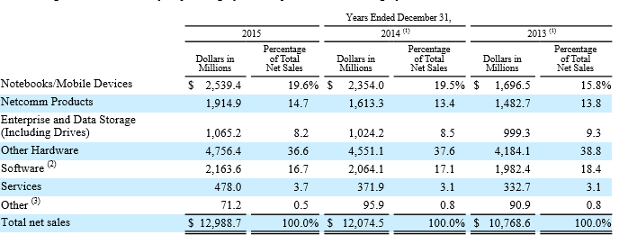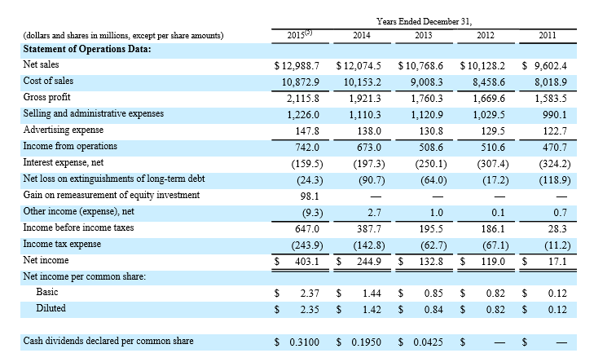
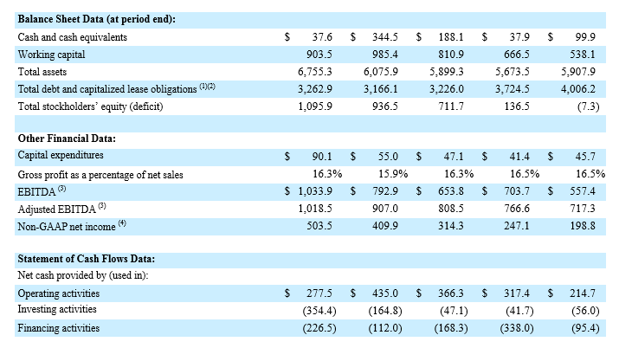
CDW Financial courtesy of (N.A., CDW 2015 Annual Report, 2016)
HP’s Financial Statements
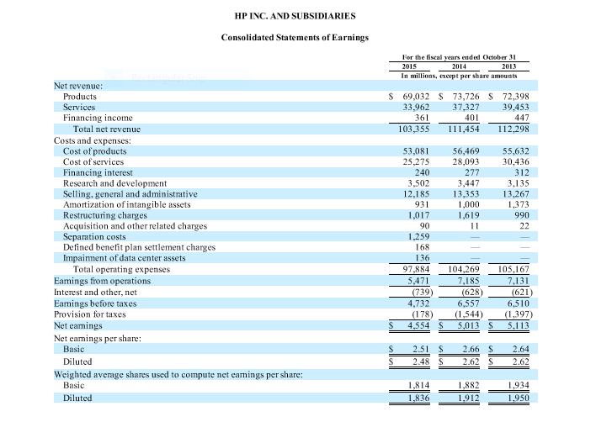
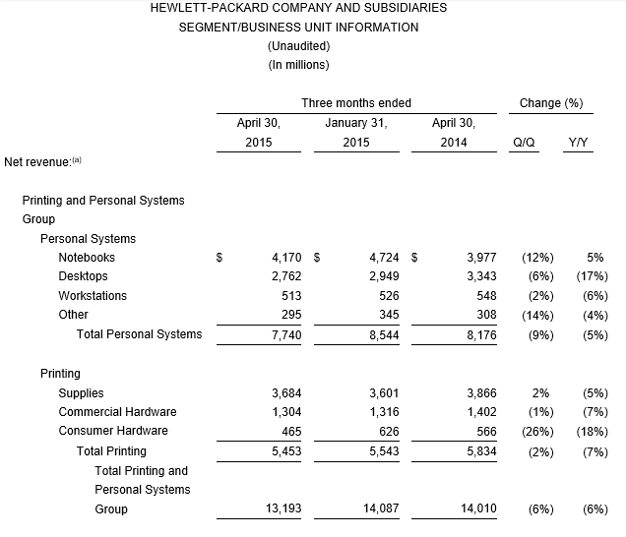
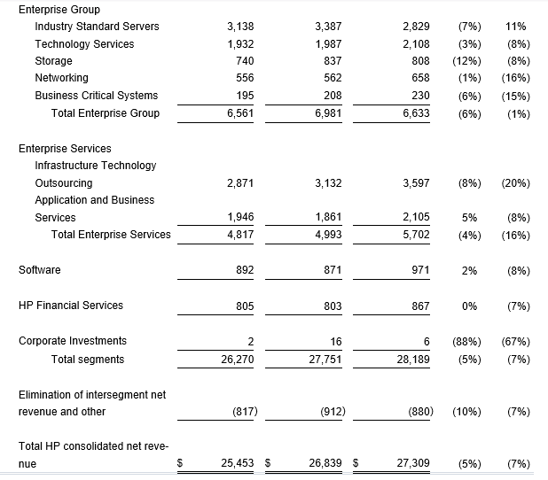
HP Financial courtesy of (N.A., 2015 10-K, 2016)
Financial Statements Analysis. While HP has been experiencing revenue decreases over the past five years, their business partner CDW has been experiencing revenue increases over the same period. Acquiring CDW, and bringing them into the HP family of companies would provide HP many financial benefits including: Taking advantage of their smaller size, as many smaller firms are able to capture business because of their specialization; taking full advantage of CDW’s financial growth to fill in current financial gaps; and making CDW an exclusive provider of HP services, which would provide HP the benefit of CDW’s continuous revenue increases.
Summary of Porter’s Five Forces
Threat of New Entrants. Starting an IT business is not difficult, but takes time, an extensive and expensive tool kit, education, certifications, licensing, strong patience and commitment, and proper funding, which is usually the reason for delay or failure of the business. In the U.S. the IT industry is an oligopoly, with a few large firms, and many smaller firms. The biggest threat to new entrants comes in the form of start-up costs and funding, and from the international marketplace, where the industry performs as monopolistic competition, which is far more competitive that the domestic market alone.
Customers Bargaining Power. In the IT world, customers bargaining power is based on size. Larger firms have more bargaining power over the supplier for the best price, and smaller firms have less bargaining power because they do not have the volume of business to leverage a lower cost. For the business consumer, service providers offer at least three levels of technology and service, to accommodate different budgets, power, data and storage capacity, and communications capabilities Realistically, a business owner needs an IT system that will meet the needs of the business, which will dictate the features, capabilities, power and cost of the system, and ultimately the cost (N.A., 2016).
Suppliers Bargaining Power. Suppliers power is based on the supplier’s ability to establish the quantities supplied and the price of the product to market, the contract terms, and the number and size of the buyers determines the suppliers power. In the IT industry, larger firms have more power over their supplier based on their size, produce their own products, or contract with reputable third party producers, and small firms have less negotiating power because of their smaller volume purchases, and will have higher supply costs. If a supplier does not consider their buyers important enough, they may price gauge or reduce the quality to generate higher profits, and their buyers will ultimately contract with another supplier. Smart suppliers will realize that today’s small firm can become tomorrow’s large firm, and place that supplier in a profitable partnership (Ryszard, 2014).
Substitute Products or Services and their threat. Since the Information Technology Standards Committee (ITSC) establishes IT standards, which encourage cost and risk reductions, product differentiation, and ensure IT industry equipment and systems compatibility, one manufacturers component is compatible with that of another manufacturer (N.A., Singapore IT Standards, 2016). Since most IT component manufacturers follow industry standards, the threat of substitute products, services and solutions is very real, but some firms still offer proprietary systems, so clients must be mindful and ask questions regarding compatibility and expansion, to make the most informed choice about the system they purchase (N.A., Singapore IT Standards, 2016).
Competitive Rivalries and their Intensity. There are several rivalries that specifically involve HP including: The 2005 race between Intel and AMD to produce dual core microprocessors, that HP was planning to use in their new servers, which IBM, Sun Microsystems, and Azul had already started shipping (McCarthy, 2005); The 2009 race between HP and Dell for diversification, with HP in the lead, and Dell responding with similar diversification, and since becoming a major player in the IT industry (N.A., HP, Dell rivalry hinges less on selling PCs, 2009); and lastly, HP’s plans of overpowering Dell and Cisco with their introduction of open platform servers, and Open Flow software defined network servers. The plan was successful, and HP absorbed two thirds of Cisco’s lost market share, thanks to Cisco’s more-costly “intelligence” switches, but with Dell introducing their open network technology, and the three are still dueling (Bort, 2012).
The Unification of Objectives and Values
Both HP and CDW offer similar products, services and business solutions, and share similar objectives and values: Centering all activities around meeting the client’s needs, teamwork makes the dread work, uncompromised passion and integrity, meeting their commitments, putting the client first, addressing conflicts head on, and only successful dealings are win/win. Unification of objectives and values will require a meeting of the minds, with all stakeholders from both firms present including: Top management, IT management and finance. All parties will participate, provide their input, and agree on one set of goals and values, sign the agreement, and the agreement will function as the cornerstone of negotiations. The agreement will act as a prerequisite and part of the actual acquisition negotiations.
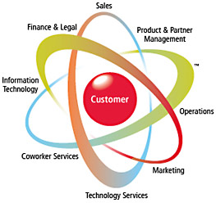
Graphic courtesy of (N.A., CDW Homepage, 2016)
Conclusion
The acquisition of CDW by HP is a natural progression for both. CDW already provides a major portion of HP’s IT services, and has seen tremendous growth, thanks to their industry partnership with HP, would fit with HP’s history of acquiring their business partners, and would improve HP’s financial position. The blending of the two IT companies would provide immense innovation and revenue boost for both, and would alter the IT industry for years to come. HP and CDW would be the IT industry leaders, and the competition would be forced to contend with a larger and more powerful IT industry giant.
Phase 5: Project Management Plan
Initiating
Project Plan initiation starts with the meeting of the minds of HP and CDW, with all stakeholder’s present including: Top management of both firms, IT department heads, and Heads of Finance. The meeting will require participation and input from all parties, will conclude with agreement on one cohesive set of goals, values and mission, the agreement will be signed by all parties, will act as the good faith gesture for both firms, and as the cornerstone for all future negotiations.
Additionally, both PMO’s will come to agreement regarding the needs and required capabilities of the updated system, along with additional processes and applications necessary to meet the new demands. PMO’s will establish top management’s full understanding of why updating the system is necessary, and secure approval from both top management and finance for the project.
Planning
To achieve desired results, proper planning is necessary, or the project will fail. To ensure the desired results the following steps will be implemented:
- Scope. Once agreement on one mutual set of goals, values and mission has been established, signed by all parties, and HP and CDW IT management has agreed on the new needs of the SIS, the project will begin and include (Durgin, 2016):
- The initial scope of the project will be the analysis and evaluation of the current infrastructure of HP and CDW. A project cycle plan will be established using MS Project, and extensive use of Gannt Charts, stipulating all facets including: Start and finish date, phases, time, resources, cost, team member assignments, responsibilities and accountability, scheduling, budget, and milestones. This process will ensure everything is well documented, and goes smoothly.
- Once acquisition negotiations are completed, the next step of planning will begin
- The scope will expand to include planning for all necessary improvements of both infrastructures. A second project cycle will be planned using MS Project, extensive use of Gannt charts, again stipulating all facets of the project and include: start and finish dates, phases, time, resources, cost, team member assignments, responsibilities and accountability, scheduling, budget and milestones. Again, this process is applied to ensure full documentation, and a smooth transition.
- The project will conclude with the updated SIS passing all testing, all users connected to the system, and meeting all requirements stipulated by the project.
- A full risk management plan to include potential problems and contingency plans to overcome them will be established, minimize or eliminate time and cost increases, and establish software security needs and employee security protocol.
- An HP and CDW IT Project Management Officer (PMO) will be assigned to oversee the entire project and work in full cooperation, each division of HP will have their own team, each of CDW’s 25 offices will have their own IT team, each team will have an IT manager, team members with expertise and experience in IT system design and implementation, testing and evaluation, and management to handle ordering supplies and paying suppliers.
- The PMO’s will be responsible for establishing and maintaining the full understanding and support of top management and finance.
- Contingency plans will be established to overcome anticipated problems that commonly arise.
- Each project team will follow established Gannt charts schedules, and fully document their progress and contingencies implemented.
- Integration. Integration will be achieved through strong communications between all IT teams, weekly team meeting to assess progress, issues that were addressed and why, fully document all project decisions, and routine technical status reviews to ensure all team members are up to speed.
- Cost. The cost of the infrastructure evaluation phase should be minimal, as it is a normal part of the IT department function. The cost of updating for compatibility and meeting new needs will be based on the necessary updates including materials and labor, and will be computed based on the completed analysis of the current systems.
- Time. The time frame for the initial evaluation will be four months, which will provide sufficient time for proper analysis of the current systems, as well as time for planning the next phase of updating the systems to meet new needs. The time frame for updating the systems will be based on the extent of the work required, and will be performed in a reasonable timely basis.
Executing
All well-established project plans must be executed properly or the expected results will not be realized, and the project will likely fail. To ensure all results meet desired expectations, the following steps will be followed:
- Each team will follow established Gannt Chart parameters specifying start and finish dates, phases, time, resources, costs, team member assignments, responsibilities and accountability, schedules, budget and milestones.
- Realizing problems will arise, and schedules and budgets are best guestimates, if costs and time increased occur, the reasons must be fully documented and justified with the team manager, and approved by the PMO. Gannt Charts will be adjusted for all cost and schedule changes.
- If cost increases and schedule extensions occur, all efforts will be made to keep projects on schedule and on budget.
- Weekly meetings with all IT teams present to provide updates on project progress and contingencies applied.
- The PMO’s will communicate project progress, issues and contingencies, and all budget and schedule changes to top management, to maintain their full understanding and support, and to reassure them all efforts will be made to complete the project on schedule and budget.
- The PMO’s will maintain plan parameters, and minimize or eliminate scope creep through routine reminders to all stakeholders of established plan parameters.
Procurement. As the project sponsor, all equipment and supplies will be provided by HP’s production facilities, and HP family of companies. This will ensure the required quality of all components, and a fully compatible SIS.
Quality. All components will be quality tested at the factory level to ensure they meet all industry and HP quality standards.
Risk Management. To properly minimize and manage risk, the following steps will be applied (Durgin, 2016):
- Implementation of the Project Cycle Plan, and Gannt charts to minimize project complexity through phases, provide clarity for each phase, fully documents requirements and expectations, leave no questions pertaining to work to be performed or resource requirements, and keep team focus on each phase.
- Implementation of a full risk management plan to include potential problems and contingency plans to overcome them will be in place, and minimize or eliminate time and cost increases.
- Weekly meetings via video conference, with all IT teams present to provide updates on progress, any problems and contingencies applied, keep all teams current on project plans, expectations, cost and time schedules, and full documentation of all information presented, decisions, and conclusions. All meeting documentations will function as the guide to resolve future issues, and address any disagreements that may occur during current and future phases.
- Implementation of all necessary security measures including: Software, firewalls, access protocols, and Smart Card badges to ensure the optimal security of all company data, and facilities.
- Security access level based on employee background checks
- Password access set to three attempts, as to prevent hackers from unlimited access attempts.
Human Resources. To ensure compliance with both the acquisition agreement and HP guidelines, hiring and continued employment procedures will include:
- All employees, current and new, passing full background checks including criminal records, and drug testing.
- All employees will be provided Smart Cards ID’s, with photo, building access security level access encoded on the card, will provide mainframe access levels, and will be needed to access their computer, and the network.
Monitoring and Controlling.
Monitoring and controlling of all aspects of the project will be addresses through the following (Durgin, 2016):
- Control gates at established points in the project, to verify project work completed meets performance requirements, and functions as designed to.
- Control gates that do not meet requirements, all necessary adjustments will be made to ensure all components perform to project requirements.
- Weekly meeting will also provide IT leaders with full details regarding progress, any problems, and contingencies applied.
Stakeholder Management. Stakeholder management will be handled by the PMO’s, will be necessary to avoid scope creep, and will provide the project all of the following (Durgin, 2016):
- Establish total commitment from all stakeholders including top management, finance, and each IT team.
- Provide routine reminders to all stakeholders of the importance of the project, and the established scope of the project.
- Ensure all phase requirements are clear and concise, and are fully understood by team members, and stakeholders.
- Assign the most experienced and capable IT manager and team members to each team, as to ensure complete clarity of each phase, team expectations, and adhesion to all project requirements.
Communications. Because routine communications are essential for any project to stay on track, the following steps will be implemented:
- A weekly team meeting, with HP’s PMO overseeing the meeting, and all teams and stakeholders present, to keep team members and stakeholders up-to-date on project progress, any problems and contingencies applied.
- At each meeting, commendations for excellent performance will be presented to team members and entire teams, that complete their assignments and phases at or below budget, and in the specified time frame or less, without sacrificing quality.
- PMO’s and Team Managers will also be available via phone or email, in the event communications cannot wait for the weekly update. This is necessary to ensure all team members can reach the appropriate authority in the event a decision is required immediately. This will avoid unnecessary cost and time delays.
Closing
The project will be considered closed when all systems are tested and perform to meet the information and communication requirements as specified by project specifications, all users are fully linked into the system, the project sponsors (HP and CDW) and PMO’s are satisfied with the SIS performance and results, and sign off on the project as complete.
Gauging Success
The project will be considered a complete success when the following requirements are met including:
- The project was completed in the established time and costs determined in the project agreement.
- All systems perform to project requirements, and meet all the data, storage, information and communication needs of HP, CDW, and its family of companies.
- The system improvements prove beneficial to meeting customer needs, improved the speed and success rate of future contracts, increase profitability and customer satisfaction.
- The system improvements have met or exceed the Return on Investment (ROI) goal
- The system improvements were effective in helping HP and CDW meet the business strategy goals.
Summary
The project will be in two stages, first the analysis and evaluation process of HP’s and CDW’s current infrastructure, and second, the implementation and execution of the new requirements. The new SIS will provide CDW full access to HP and their family of companies, will encourage collaboration and cooperation, increase innovation, productivity and profitability, and foster a long and prosperous relationship.

References
Bort, J. (2012, February 27). HP Has Big Plans To Knock The Socks Off Cisco And Dell. Retrieved from Business Insider: www.businessinsider.com/hp-has-big-plans-to-knock-the-socks-off...
Competition in The Information Technology Industry. (2009, March 9). Retrieved from wikinvest: www.wikinvest.com/stock/TERADATA_CORP_(TDC)/Competition-the...
Durgin, J. (2016, May 2). Live Chat 5: IT600 02 288 6 3 0 5. Retrieved from CTU online: www.ctuonline.edu/live chat 5/it600022886305
Eckel, E. (2008, December 10). The industry's 10 best IT certifications. Retrieved from www.techrepublic.com/.../the-industrys-10-best-it-certifications
Hughes, S. (2010, August 3). Five Critical Success Factors for Project Managers. Retrieved from NC STATE: Industry Innovation Solution: https://www.ies.ncsu.edu/blog/five-critical-success-factors-for...
Jurevicius, O. (2013, September 14). Mission statement of HP. Retrieved from Strategic Mangement Insight: https://www.strategicmanagementinsight.com/mission-statements/hp...
Kelchner, L. (2016). The Advantages of a Product Differentiation Strategy. Retrieved from Chron: smallbusiness.chron.com › … › Product Strategies
Korngold, A. (2012, January 18). Hewlett Packard's Corporate Global Vision. Retrieved from Fast Company: www.fastcompany.com/1809130
McCarthy, J. (2005, April 22). Dual-core rivalry between AMD and Intel includes HP. Retrieved from InfoWorld: www.infoworld.com › Hardware
N.A. (2016). Porter’s Five Forces: Assessing the Balance of Power in a Business Situation. Retrieved from MindTools: https://www.mindtools.com/pages/article/newTMC_08.htm
N.A. (2009, March 9). HP, Dell rivalry hinges less on selling PCs. Retrieved from AUSTIN BUSINESS JOURNAL: www.bizjournals.com › Industry News › Technology
N.A. (2015). Top Ten Best Computer Companies. Retrieved from THE TOP TENS: www.thetoptens.com › … › Companies and Products › Computers
N.A. (2016). 2015 10-K. Retrieved from HP Investor Relations: h30261.www3.hp.com › Financial
N.A. (2016). Annual Financials for Oracle Corp. Retrieved from MarketWatch: www.marketwatch.com/investing/stock/ORCL/financials
N.A. (2016). CDW 2015 Annual Report. Retrieved from CDW FINANCIAL INFORMATION: investor.cdw.com/financials.cfm
N.A. (2016). CDW Homepage. Retrieved from CDW.com: www.aboutcdw.com
N.A. (2016). Data and Goals. Retrieved from HP.com: www8.hp.com/us/en/hp-information/global-citizenship/data-and-goals...
N.A. (2016). Definition: Strategic Thrusts Wiseman. Retrieved from mbasKOOL: www.mbaskool.com › Marketing And Strategy
N.A. (2016). Hewlett Packard Marketing Mix. Retrieved from Marketing Teacher: www.marketingteacher.com/hewlett-packard-marketing-mix
N.A. (2016). How to Start an Information Technology Business . Retrieved from eHow: www.ehow.com › … › Small Businesses › Starting a Small Business
N.A. (2016). IBM and alliance partner joint solutions. Retrieved from IBM: Alliances: www.ibm.com/services/us/en/it-services/alliances
N.A. (2016). IBM: Cognitive Systems. Retrieved from IBM.com: www.IBM.com/outthink
N.A. (2016). Innovation and the CIO: 5 Great Ideas. Retrieved from ORACLE: Innovation: www.oracle.com › About
N.A. (2016). Oracle Business Services. Retrieved from ORACLE: www.oracle.com › … › Professional Services › Business Services
N.A. (2016). Singapore IT Standards. Retrieved from iTSC: https://www.itsc.org.sg
N.A. (2016). Timeline of our history. Retrieved from HP HIstory: www8.hp.com › HP History
Phadnis, S. (2014, April 22). TCS joins top 10 global IT services companies club. Retrieved from THE TIMES OF INDIA: timesofindia.indiatimes.com/tech/tech-news/TCS-joins-top-10-global...
Ryszard, B. (2014). Bargaining Power Of Suppliers. Retrieved from Strategic Management: Formulation and Implementation: www.strategy-formulation.24xls.com/en113
Shobhit, S. (2016). World's Top 10 Software Companies . Retrieved from Investopedia: www.investopedia.com/.../121714/worlds-top-10-software-companies.asp

